Main window:

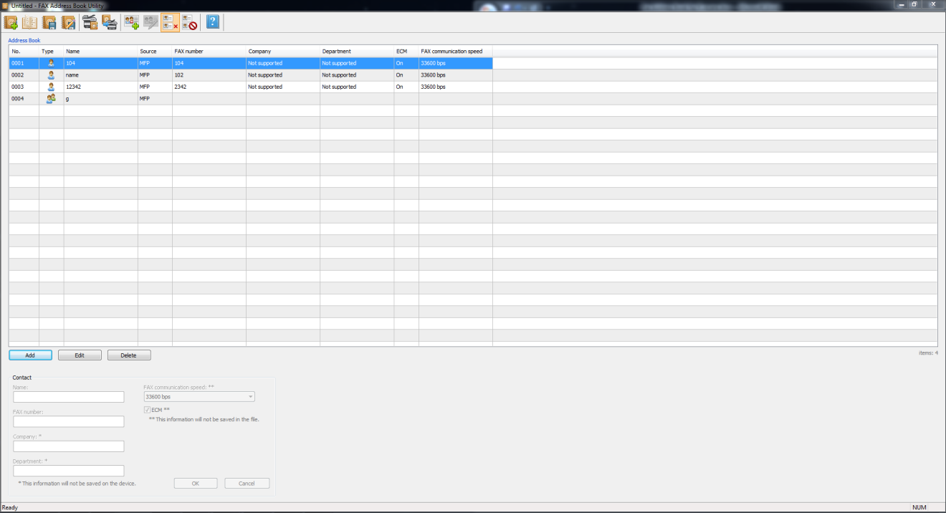

Load from device

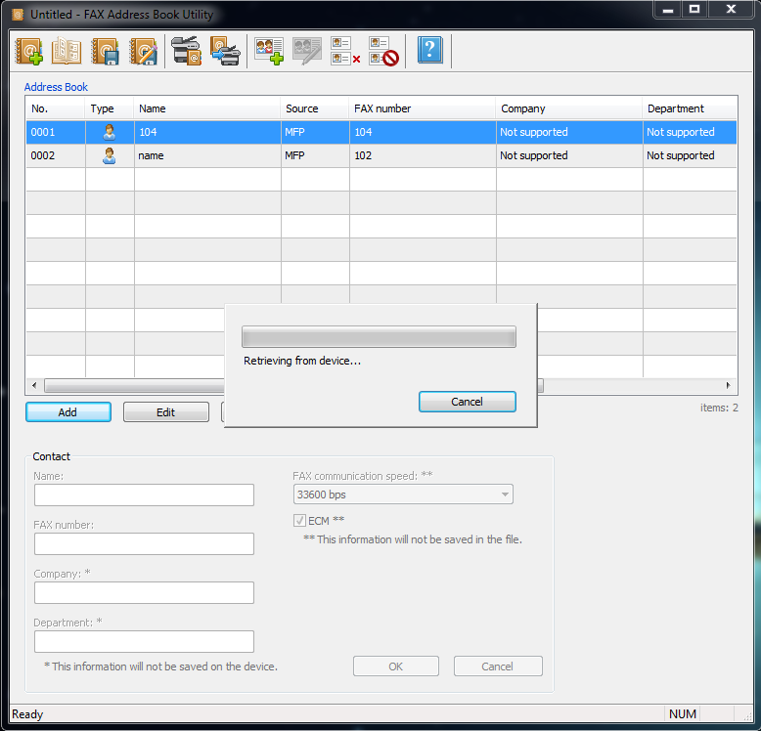

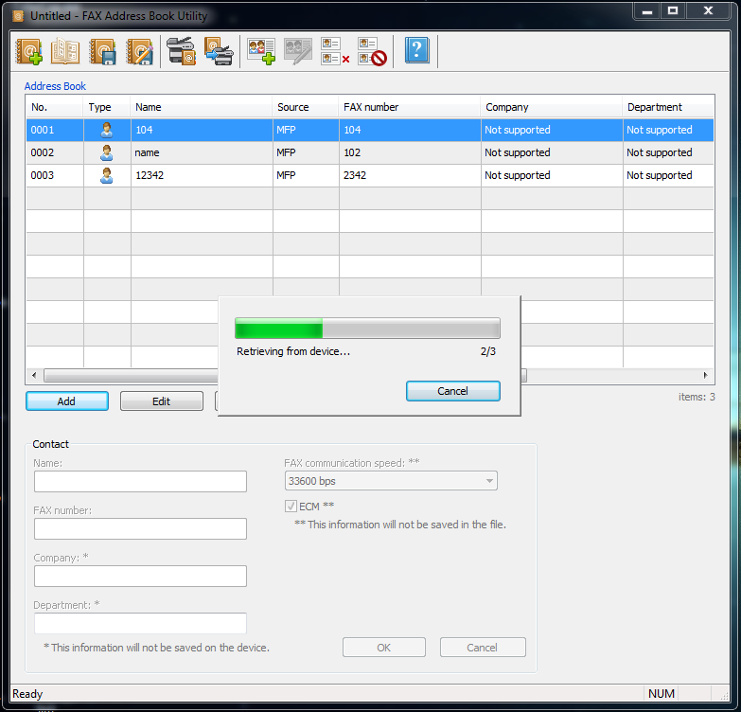

Save to device

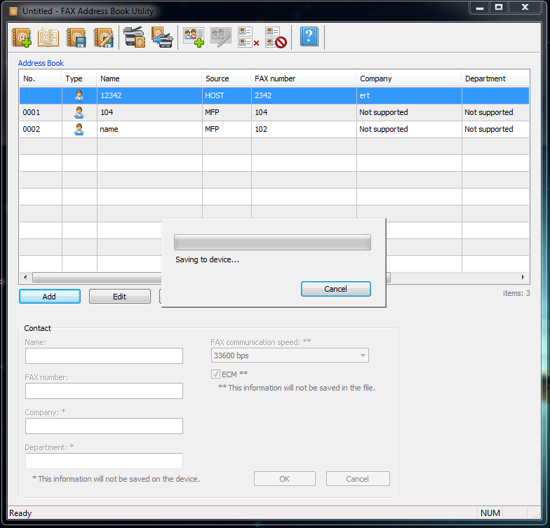

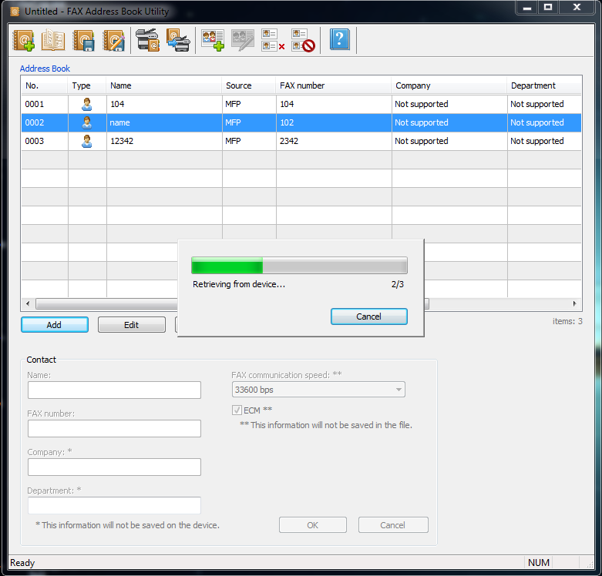

add data , no save and clicked Load from device:

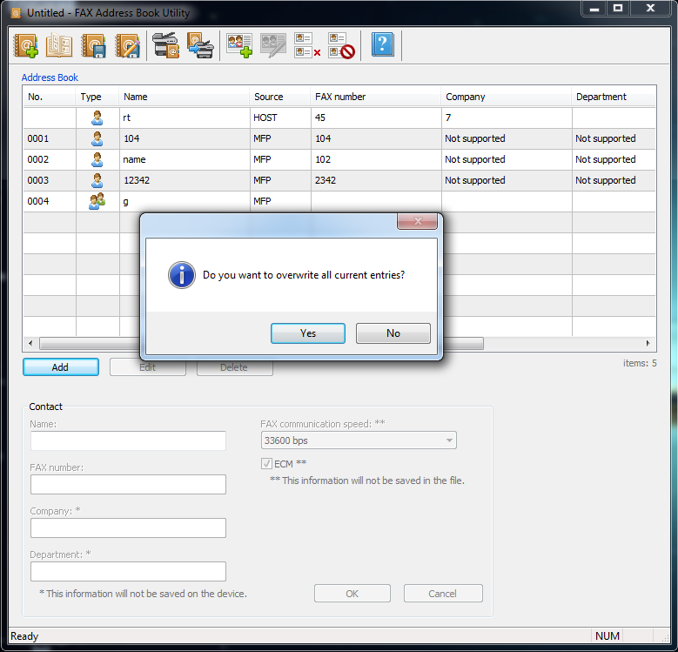

Blocked Numbers:

1.open loading 2.open loaded

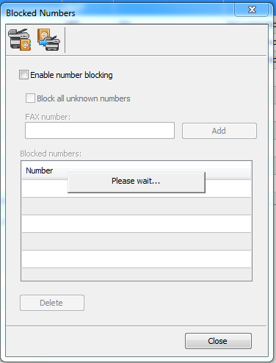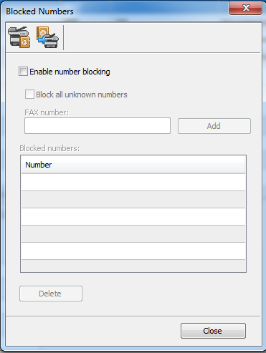

Load from device Enable number blocking checked

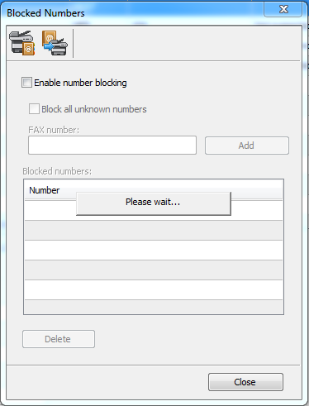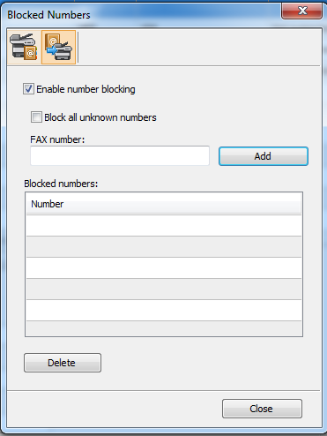

empty FAX number and clicked Add button:

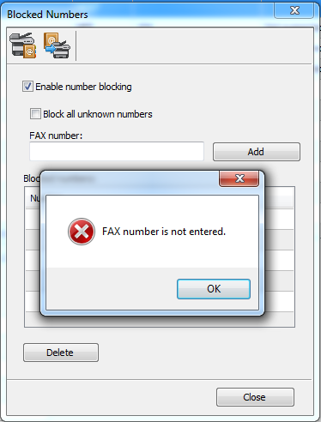

input invalid FAX Number and clicked Add button.

clicked OK button, clear the invalid FAX number:

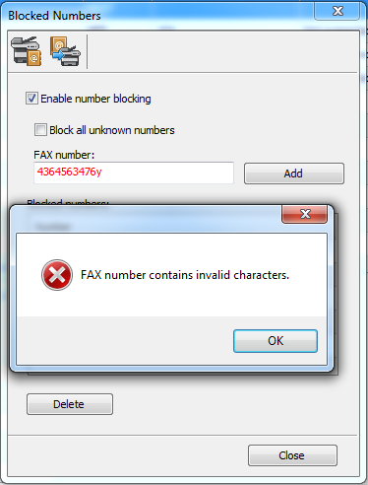

Checked Enable number blocking, input data and add, unchecked it:

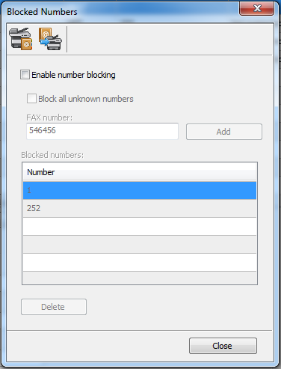

checked Block all unknown numbers:

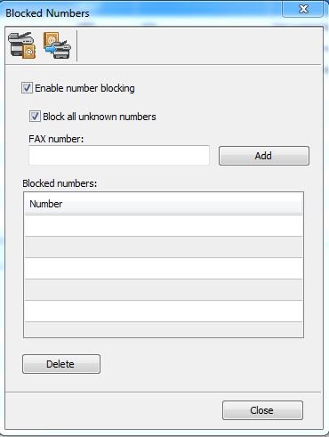

Checked or Unchecked Block all unknown numbers, input existed FAX number:

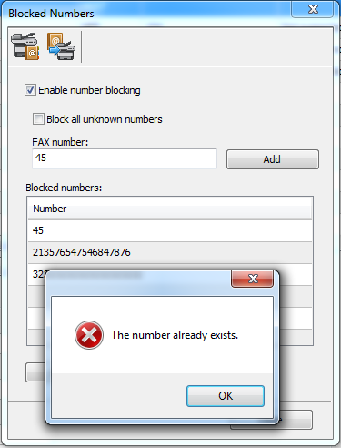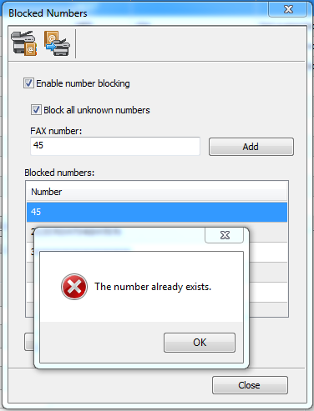

Save to device and saved:

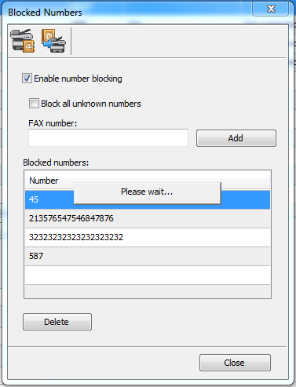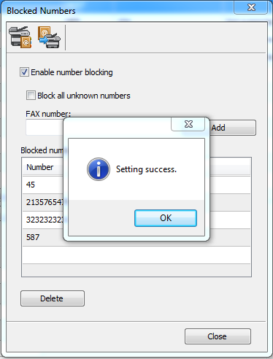

no save and clicked close:

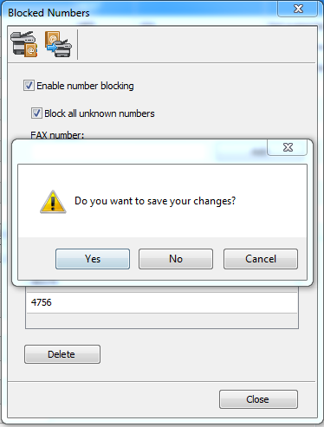

keeping connected, open Blocked Numbers dialog. disconnect and clicked open Blocked Numbers Dialog:

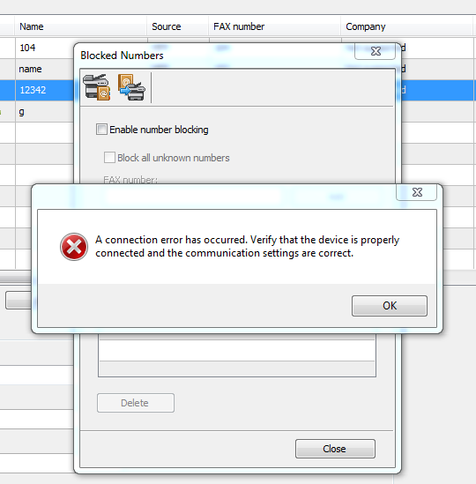

keeping connected, open Blocked Numbers dialog. disconnect and clicked Load from device:

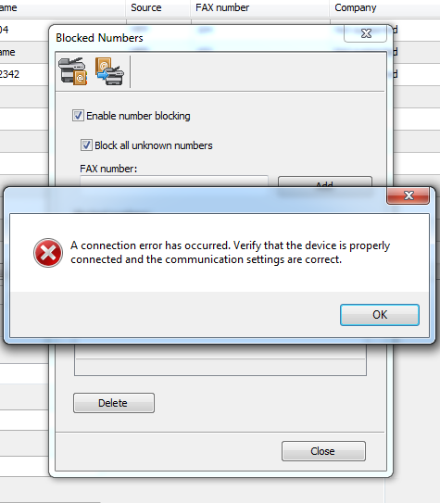

keeping connected device, open Blocked Numbers dialog. add data, disconnect and clicked save to device:

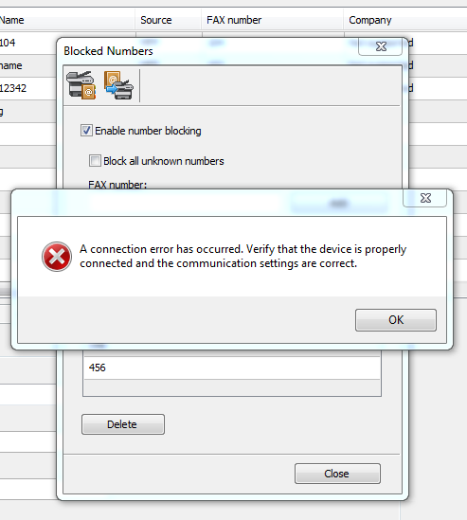

keeping connected device, open Blocked Numbers dialog. add data no save and close.

clicked Yes:

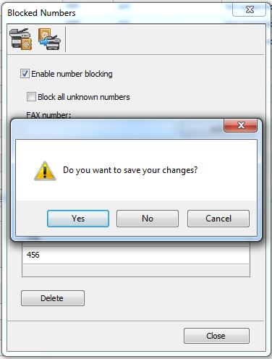 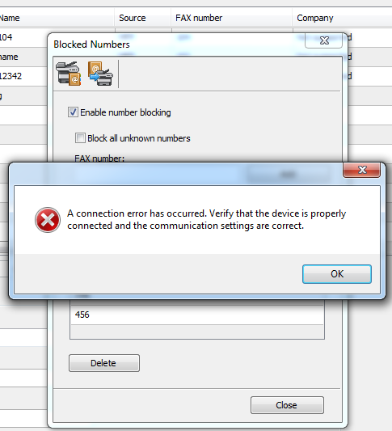

keeping connected. clicked Load from device Button or Save to device:

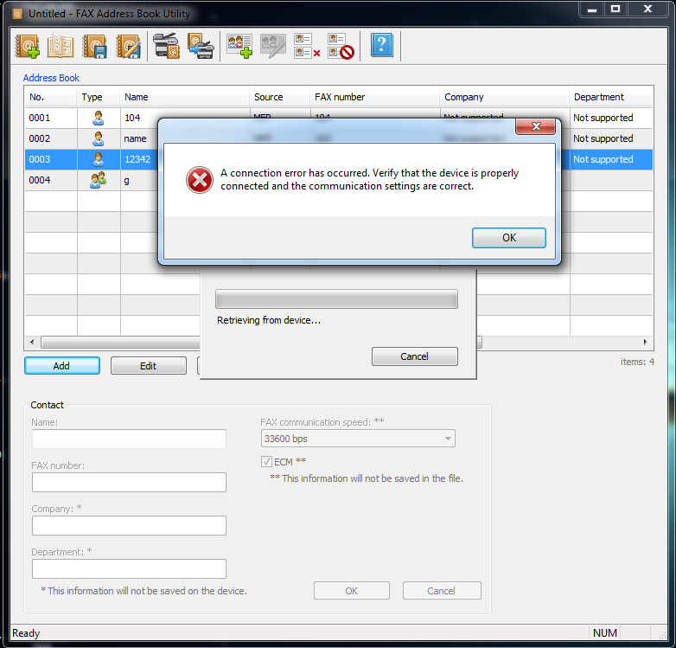

**UI Client**

**Driver**

**Device Data**

**Local**

**Data**

Address Book Utility Framework

**View2**

**View...n**

**Client**

**View1**

**Model**

Controller

**Data**

**Entry**

**Device** **Data**

**Local** **Data**

Read/Write

Read/Write

Query

Show data

1.Handle request

2.Select view to show

Status changed

Update

Data structure

Model/View design

**<namespace>**

**AddressBook**

**AddressBook**

**Application**

PrinterIODevice

EntryItem

EntryModel

FileIODevice

AbstractIODevice

Driver Read/Write

Address Book File

AbstractEntryModel

Controller

ListView

Application

